**Using ChatGPT to Generate Book Summaries: Prompt and Outcome**

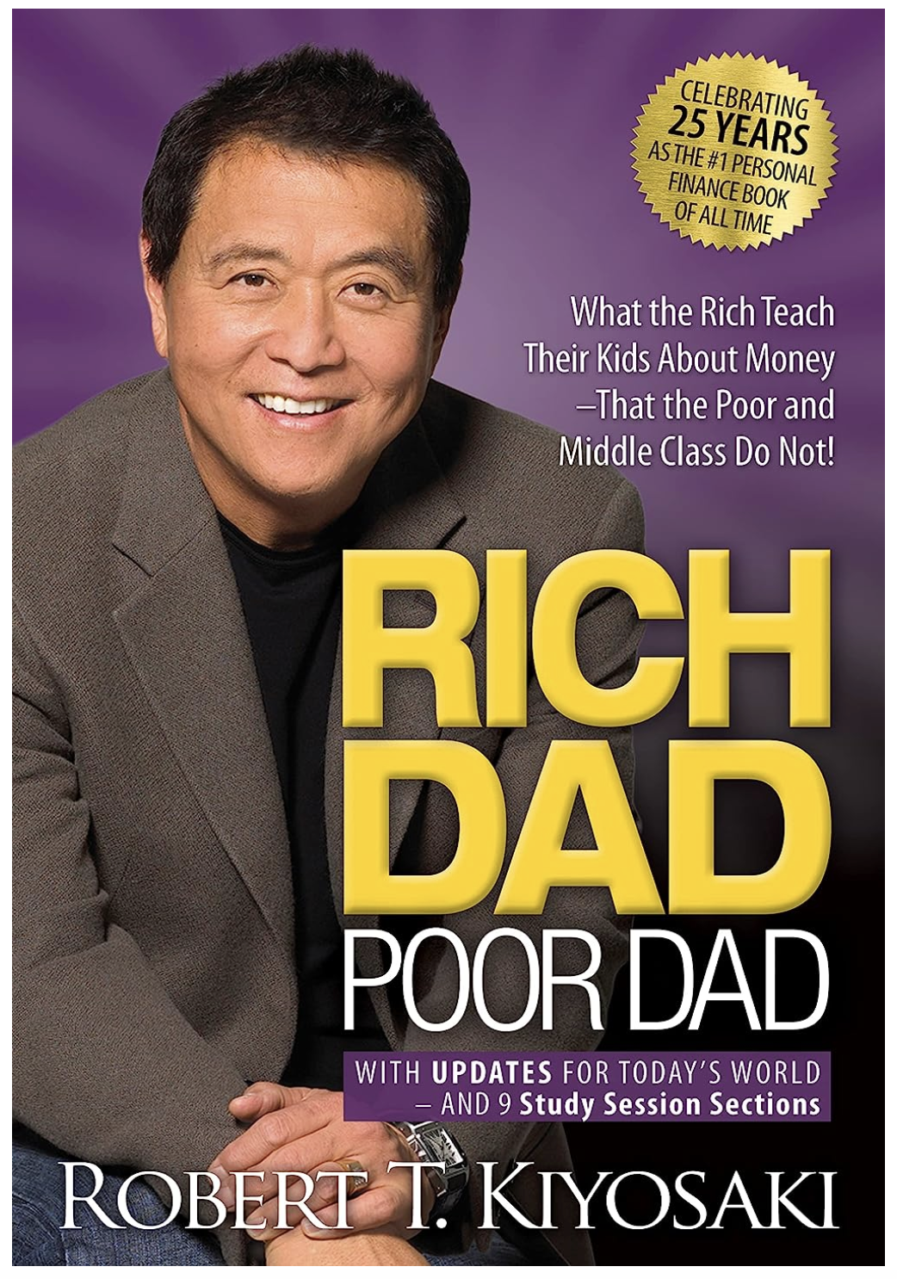

**Prompt**

Summarize the book rich dad, poor dad by the author robert kiyosaki and give me a list of the most important learnings and insights.

**Outcome**

"Rich Dad, Poor Dad" is a personal finance book written by Robert Kiyosaki that highlights the differences in mindset and habits between his "rich dad" (his best friend's father) and his "poor dad" (his biological father). The book presents a series of lessons and anecdotes that illustrate how the rich think differently about money and how they use it to create wealth.

Some of the most important learnings and insights from the book include:

1. The difference between assets and liabilities: According to Kiyosaki, an asset is something that puts money in your pocket, while a liability is something that takes money out of your pocket. He suggests focusing on acquiring assets rather than liabilities.

2. The importance of financial education: Kiyosaki argues that the traditional education system does not provide adequate financial education and that it is up to individuals to seek out financial knowledge and learn how to manage their money effectively.

3. The power of passive income: Kiyosaki emphasizes the importance of creating passive income streams, such as rental income or dividend income, which can generate income even when you are not actively working.

4. The value of taking calculated risks: Kiyosaki encourages readers to take calculated risks in order to create wealth, rather than simply playing it safe and settling for a steady paycheck.

5. The importance of entrepreneurship: Kiyosaki believes that entrepreneurship is a key pathway to creating wealth and achieving financial freedom, and encourages readers to explore starting their own businesses.

6. The concept of paying yourself first: Kiyosaki suggests making saving and investing a priority by paying yourself first before paying any bills or expenses.

7. The role of mindset in wealth creation: Kiyosaki stresses the importance of developing a mindset focused on abundance and possibility, rather than scarcity and fear.

Overall, "Rich Dad, Poor Dad" challenges readers to reevaluate their relationship with money and to adopt a new perspective on wealth creation. It emphasizes the importance of financial education, entrepreneurship, and taking calculated risks in order to build wealth and achieve financial freedom.